**LAPORAN PRAKTIKUM**

**PENGOLAHAN CITRA DAN VISI KOMPUTER**

**WEEK 5: Histogram, Histogram Equalization, Dithering**



**Disusun Oleh :**

Ghoffar Abdul Ja’far 2341720035/TI3H

**JURUSAN TEKNOLOGI INFORMASI**

**POLITEKNIK NEGERI MALANG**

**2025/2026**

* Nama: Ghoffar Abdul Ja'far

NIM: 2341720035

Kelas: TI 3H

* MODUL 5 - Histogram, Histogram Equalization, Dithering
* D. PERCOBAAN PRAKTIKUM

# D-1 PERCOBAAN HISTOGRAM

from google.colab import drive drive.mount('/content/drive')

Drive already mounted at /content/drive; to attempt to forcibly remount, call dr

import cv2 as cv

from google.colab.patches import cv2_imshow from skimage import io

import matplotlib.pyplot as plt import numpy as np

import math import os import glob

#membuat histogram image (manual)

img = cv.imread('/content/drive/MyDrive/PCVK/Images/lena.jpg') img = cv.cvtColor(img, cv.COLOR_BGR2RGB)

height, width, depth = np. shape (img) names = np.arange(256)

red = [0]*256 green = [0]*256 blue = [0]*256

for y in range(0,height) : for x in range(0,width) :

red [img [y] [x] [0]] += 1

green [img [y] [x] [1]] += 1

blue [img [y] [x] [2]] += 1

names = np.arange(256)

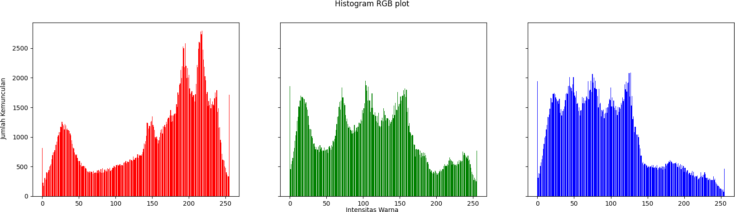

<BarContainer object of 256 artists>

fig, axs = plt.subplots(1, 3, figsize=[20,5], sharex=True, sharey=True)

fig.suptitle('Histogram RGB plot')

fig.text(0.09, 0.5, 'Jumlah Kemunculan', va='center', rotation='vertical') fig.text(0.5, 0.04, 'Intensitas Warna', ha='center')

axs[0].bar(names, red, color='red') axs[1].bar(names, green, color='green') axs[2].bar(names, blue, color='blue')

* PERTANYAAN PRAKTIKUM D1
  1. Buatlah histogram citra yang sama akan tetapi menggunakan library yang dimiliki oleh NumPy yaitu “histogram”. Bandingkan hasilnya. Apakah output muncul sama?

# Pisahkan channel R = img[:, :, 0]

G = img[:, :, 1]

B = img[:, :, 2]

# Histogram dengan numpy

hist_R, _ = np.histogram(R, bins=256, range=(0, 256)) hist_G, _ = np.histogram(G, bins=256, range=(0, 256)) hist_B, _ = np.histogram(B, bins=256, range=(0, 256))

# Plot

fig, axs = plt.subplots(1, 3, figsize=[20,5], sharex=True, sharey=True)

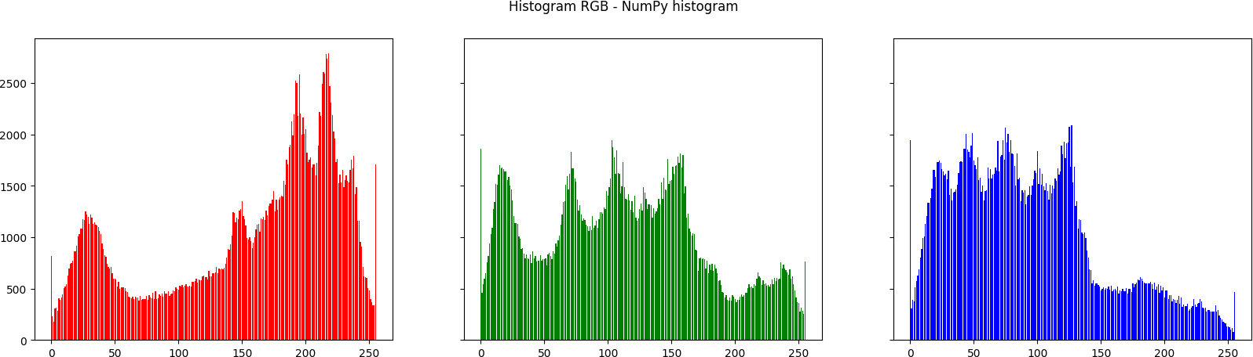

fig.suptitle('Histogram RGB - NumPy histogram')

axs[0].bar(names, hist_R, color='red') axs[1].bar(names, hist_G, color='green') axs[2].bar(names, hist_B, color='blue') plt.show()

* 1. Buatlah histogram dengan menggunakan dengan menggunakan image KTM lama.jpg. Analisis distribusi intensitas dari histogram yang dihasilkan apakah gambar cenderung gelap, terang, atau kontras rendah



# Baca gambar KTM

img = cv.imread('/content/drive/MyDrive/PCVK/Images/KTM lama.jpg')

# Ubah ke grayscale (analisis intensitas lebih mudah di grayscale) gray = cv.cvtColor(img, cv.COLOR_BGR2GRAY)

# Histogram intensitas grayscale

hist, bins = np.histogram(gray, bins=256, range=(0, 256))

# Plot plt.figure(figsize=(10,5))

plt.bar(np.arange(256), hist, color='black') plt.title('Histogram Intensitas - KTM lama') plt.xlabel('Intensitas (0=gelap, 255=terang)') plt.ylabel('Jumlah Piksel')

plt.show()

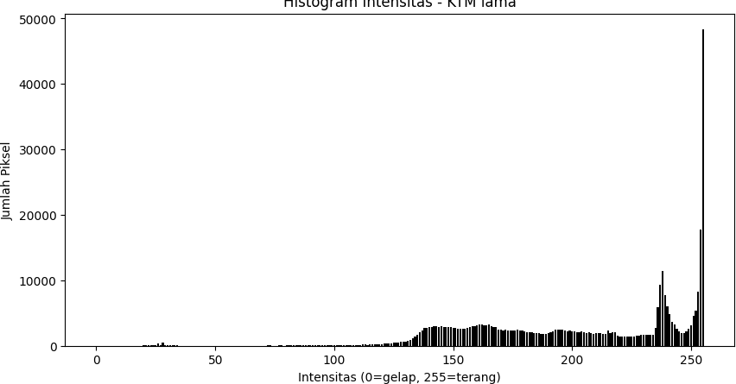

# D-2 PERCOBAAN HISTOGRAM EQUALIZATION

# Step 1: Input image (lena_lc.jpg)

img = cv.imread('/content/drive/MyDrive/PCVK/Images/lena_lc.jpg') img = cv.cvtColor(img, cv.COLOR_BGR2RGB)

# Step 2: Menghitung jumlah kemunculan setiap pixel warna (frekuensi) hist, bins = np.histogram(img.flatten(), 256, [0, 256])

# Step 3: Menghitung penjumlahan kumulatif dari frekuensi cdf = hist.cumsum()

# Step 4: Normalisasi, membagi dengan jumlah total pixel cdf_normalized = cdf * hist.max() / cdf.max()

# Step 5: Implementasi rumus k0, Normalisasi CDF

cdf_m = np.ma.masked_equal(cdf, 0) # Mengabaikan nilai 0

cdf_m = (cdf_m - cdf_m.min()) * 255 / (cdf_m.max() - cdf_m.min()) cdf_final = np.ma.filled(cdf_m, 0).astype('uint8')

# Step 6: Menerapkan CDF hasil equalization pada gambar img_equalized = cdf_final[img]

plt.figure(figsize=(12, 8))

plt.subplot(3, 3, 1) plt.imshow(img) plt.title('Gambar Original') plt.axis('off')

plt.subplot(3, 3, 3) plt.imshow(img_equalized)

plt.title('Gambar Setelah Histogram Equalization') plt.axis('off')

colors = ('r', 'g', 'b')

for i, color in enumerate(colors): plt.subplot(3, 3, 3 + i + 1)

hist = cv.calcHist([img], [i], None, [256], [0, 256]) plt.bar(range(256), hist.flatten(), color=color) plt.title('Histogram Sebelum Equalization') plt.xlim([0, 256])

plt.xlabel('Pixel Intensity') plt.ylabel('Frequency')

for i, color in enumerate(colors):

plt.subplot(3, 3, 6 + i + 1) # 3 rows, 2 columns

hist_eq = cv.calcHist([img_equalized], [i], None, [256], [0, 256]) plt.plot(hist_eq, color=color)

plt.title(f'Histogram Setelah Equalization - {color.upper()} Channel') plt.xlim([0, 256])

plt.xlabel('Pixel Intensity') plt.ylabel('Frequency')

plt.tight_layout() plt.show()

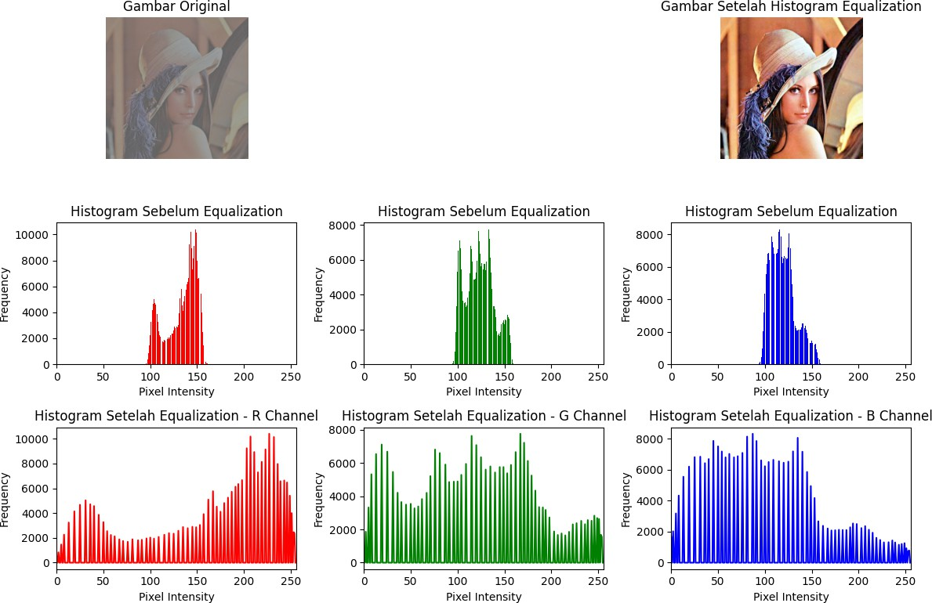

Setelah mengerjakan langkah no. 1, buatlah histogram citra yang sama akan tetapi menggunakan library yang dimiliki oleh CV2 yaitu “equalizeHist” seperti pada potongan kode berikut ini.

# Start / Input Image

img = cv.imread('/content/drive/MyDrive/PCVK/Images/lena_lc.jpg') img = cv.cvtColor(img, cv.COLOR_BGR2RGB)

# Hitung Frekuensi (histogram)

hist, bins = np.histogram(img.flatten(), bins=256, range=[0,256])

# Hitung Kumulatif Frekuensi

cdf = hist.cumsum()

# Normalisasi CDF (bagi dengan jumlah pixel dan skala ke 0-255) cdf_normalized = cdf * 255 / cdf[-1]

# Implementasi rumus transformasi equalization

img_eq = np.interp(img.flatten(), bins[:-1], cdf_normalized) img_eq = img_eq.reshape(img.shape).astype('uint8')

# Visualisasi plt.figure(figsize=(12,6)) plt.subplot(1,2,1) plt.imshow(img, cmap='gray')

plt.title("Citra Asli (Grayscale)") plt.axis("off")

plt.subplot(1,2,2) plt.imshow(img_eq, cmap='gray')

plt.title("Citra Hasil Histogram Equalization") plt.axis("off")

plt.show()

# Pisah channel RGB

R, G, B = cv.split(img)

# Equalize per channel R_eq = cv.equalizeHist(R) G_eq = cv.equalizeHist(G) B_eq = cv.equalizeHist(B)

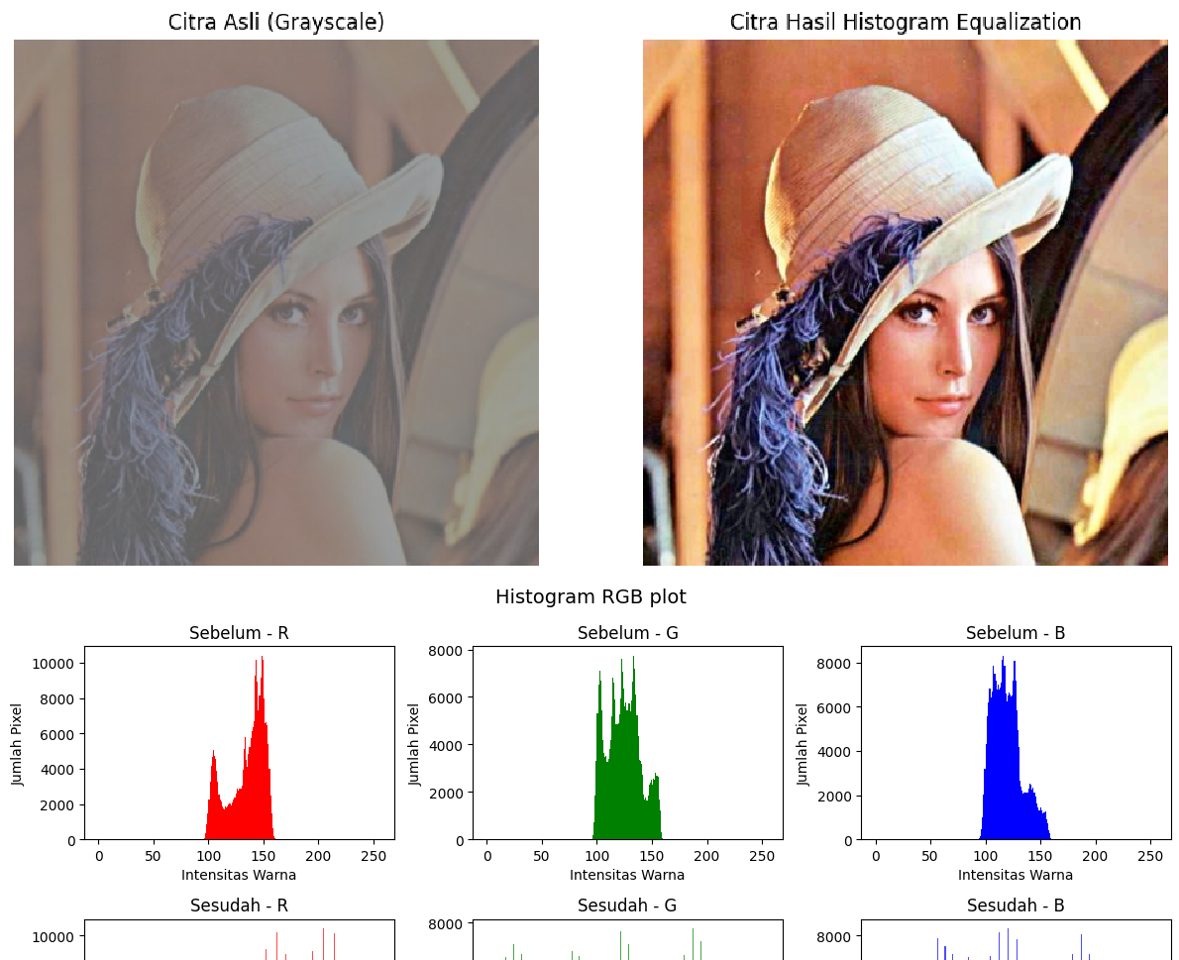

# Gabungkan kembali channels_orig = [R, G, B] channels_eq = [R_eq, G_eq, B_eq]

plt.figure(figsize=(12,6)) plt.suptitle("Histogram RGB plot", fontsize=14)

for i, col in enumerate(colors):

# Sebelum equalization (baris atas) plt.subplot(2,3,i+1)

plt.hist(channels_orig[i].ravel(), bins=256, range=(0,256), color=col) plt.title(f"Sebelum - {col.upper()}")

plt.xlabel("Intensitas Warna") plt.ylabel("Jumlah Pixel")

# Sesudah equalization (baris bawah) plt.subplot(2,3,i+4)

plt.hist(channels_eq[i].ravel(), bins=256, range=(0,256), color=col, alpha= plt.title(f"Sesudah - {col.upper()}")

plt.xlabel("Intensitas Warna") plt.ylabel("Jumlah Pixel")

plt.tight_layout() plt.show()

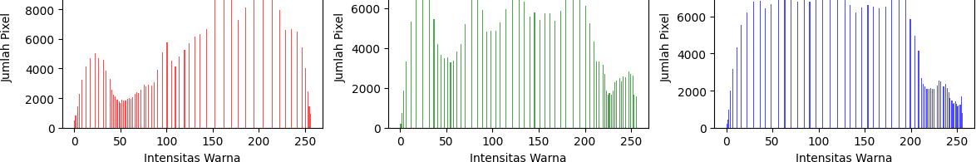

# PERTANYAAN PRAKTIKUM D2

* 1. Perbandingan Citra Lena
     + a. Gunakan hasil histogram equalization pada citra lena.jpg.
     + b. Hitung nilai PSNR antara citra asli dan citra hasil equalization.
     + c. Apakah nilai PSNR tinggi atau rendah? Apa arti nilai tersebut terhadap kualitas visual citra? Apakah ada detail baru yang muncul setelah equalization?

# PSNR

def compute_psnr(img, img_eq):

mse = np.mean((img.astype(np.float64) - img_eq.astype(np.float64)) ** 2) if mse == 0:

return float('inf')

PIXEL_MAX = 255.0

psnr = 10 * np.log10((PIXEL_MAX ** 2) / mse) return psnr

psnr_rgb_equalized = compute_psnr(img, img_eq)

print("PSNR (original vs equalize per-channel RGB):", psnr_rgb_equalized)

PSNR (original vs equalize per-channel RGB): 12.98588185586433

* 1. Gunakan Citra KTM Lama.jpg
     + a. Terapkan histogram equalization pada citra KTM lama.jpg.
     + b. Tampilkan citra asli, citra hasil equalization, serta histogram keduanya dalam satu layout.
     + c. Bandingkan citra KTM lama.jpg sebelum dan sesudah histogram equalization. Jelaskan perbedaan yang terlihat secara visual (misalnya pada detail wajah, teks, atau latar belakang). Apakah perubahan tersebut meningkatkan kualitas informasi dari citra atau justru membuat citra terlihat terlalu “keras”.

# Start / Input Image

img = cv.imread('/content/drive/MyDrive/PCVK/Images/KTM lama.jpg') img = cv.cvtColor(img, cv.COLOR_BGR2RGB)

# Hitung Frekuensi (histogram)

hist, bins = np.histogram(img.flatten(), bins=256, range=[0,256])

# Hitung Kumulatif Frekuensi cdf = hist.cumsum()

# Normalisasi CDF (bagi dengan jumlah pixel dan skala ke 0-255) cdf_normalized = cdf * 255 / cdf[-1]

# Implementasi rumus transformasi equalization

img_eq = np.interp(img.flatten(), bins[:-1], cdf_normalized) img_eq = img_eq.reshape(img.shape).astype('uint8')

# Visualisasi plt.figure(figsize=(12,6)) plt.subplot(1,2,1) plt.imshow(img, cmap='gray')

plt.title("Citra Asli (Grayscale)") plt.axis("off")

plt.subplot(1,2,2) plt.imshow(img_eq, cmap='gray')

plt.title("Citra Hasil Histogram Equalization") plt.axis("off")

plt.show()

# Pisah channel RGB

R, G, B = cv.split(img)

# Equalize per channel R_eq = cv.equalizeHist(R) G_eq = cv.equalizeHist(G) B_eq = cv.equalizeHist(B)

# Gabungkan kembali

channels_orig = [R, G, B] channels_eq = [R_eq, G_eq, B_eq]

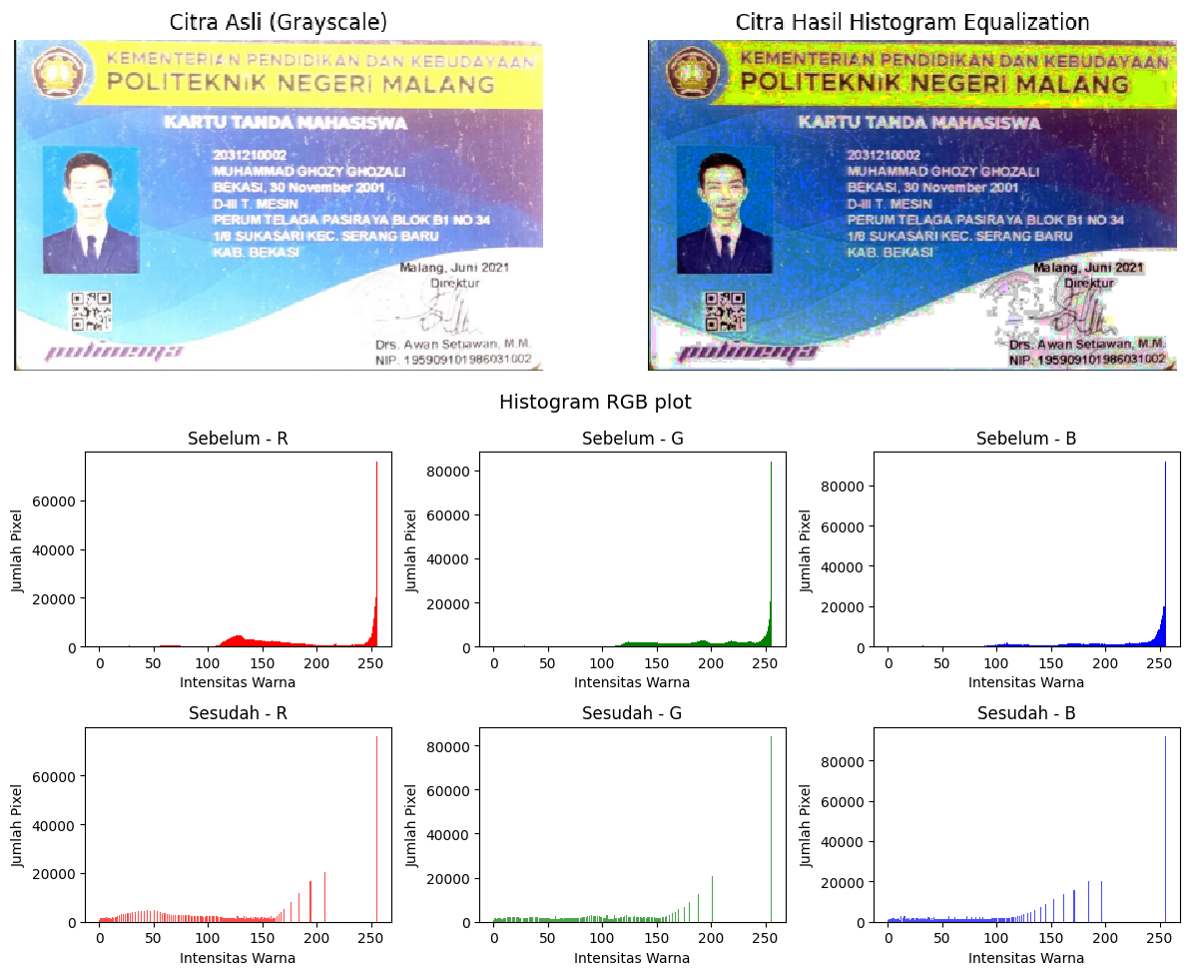

plt.figure(figsize=(12,6)) plt.suptitle("Histogram RGB plot", fontsize=14)

for i, col in enumerate(colors):

# Sebelum equalization (baris atas) plt.subplot(2,3,i+1)

plt.hist(channels_orig[i].ravel(), bins=256, range=(0,256), color=col) plt.title(f"Sebelum - {col.upper()}")

plt.xlabel("Intensitas Warna") plt.ylabel("Jumlah Pixel")

# Sesudah equalization (baris bawah) plt.subplot(2,3,i+4)

plt.hist(channels_eq[i].ravel(), bins=256, range=(0,256), color=col, alpha= plt.title(f"Sesudah - {col.upper()}")

plt.xlabel("Intensitas Warna") plt.ylabel("Jumlah Pixel")

plt.tight_layout() plt.show()

# D-3 TUGAS PRAKTIKUM DITHERING

* 1. Lakukanlah proses dithering Floyd and Steinberg seperti output berikut (tampilan image awal, dan tampilan setelah dithering) berdasarkan flowchart di bagian bawah halaman modul ini! (Gunakan gambar lena.jpg)

def threshold(value):

"""Batas biner sesuai flowchart""" if value > 255:

return 255 elif value < 0:

return 0 else:

return 0 if value < 128 else 255

def floyd_steinberg_color(image):

# copy sebagai float untuk perhitungan error h, w, c = image.shape

img = image.astype(np.float32).copy()

for y in range(h-1):

for x in range(1, w-1):

old_pixel = img[y, x].copy() # [B,G,R]

new_pixel = np.array([threshold(v) for v in old_pixel]) img[y, x] = new_pixel

error = old_pixel - new_pixel # Sebar error ke tetangga

img[y, x+1] += error * 7/16

img[y+1, x-1] += error * 3/16 img[y+1, x] += error * 5/16 img[y+1, x+1] += error * 1/16

return np.clip(img, 0, 255).astype(np.uint8)

# Load lena.jpg (warna)

img = cv.imread('/content/drive/MyDrive/PCVK/Images/lena.jpg') img = cv.cvtColor(img, cv.COLOR_BGR2RGB)

# Terapkan Floyd-Steinberg Dithering (warna) dithered = floyd_steinberg_color(img)

# Tampilkan hasil plt.figure(figsize=(10,5)) plt.subplot(1,2,1) plt.title("Original") plt.imshow(img) plt.axis("off")

plt.subplot(1,2,2)

plt.title("Floyd-Steinberg Dithered") plt.imshow(dithered)

plt.axis("off")

plt.show()

* 1. Menggunakan lena_lc.jpg rubah menjadi grey image, kemudian terapkan histogram equalization sehingga terjadi perbaikan sebaran warna pada citra. Setelah itu dari hasil histogram equalization implementasikan proses dithering Floyd and Steinberg sehingga menampilkan gambar di bawah ini!

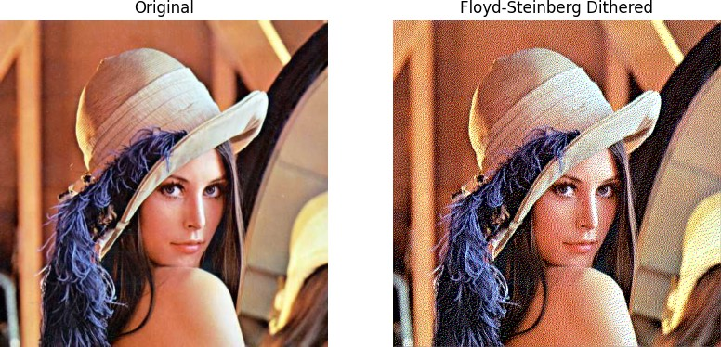

# Load the image

img = cv.imread('/content/drive/MyDrive/PCVK/Images/lena.jpg') img_ori = cv.cvtColor(img, cv.COLOR_BGR2RGB)

# Convert the image to grayscale

gray_img = cv.cvtColor(img cv.COLOR_BGR2GRAY)

# Apply histogram equalization equalized_img = cv.equalizeHist(gray_img)

# Floyd-Steinberg dithering matrix fs_matrix = np.array([[0, 0, 7],

[3, 5, 1]]) / 16

# Normalize the equalized image to have pixel values between 0 and 1 img_normalized = equalized_img.astype(np.float32) / 255.0

# Get the dimensions of the image rows, cols = img_normalized.shape

# Create a copy of the image to apply the dithering dithered_img = np.copy(img_normalized)

# Apply Floyd-Steinberg dithering for y in range(rows - 1):

for x in range(1, cols - 1): old_pixel = dithered_img[y, x]

new_pixel = np.round(old_pixel) # Quantize to either 0 or 1 dithered_img[y, x] = new_pixel

error = old_pixel - new_pixel

# Distribute the error to neighboring pixels dithered_img[y, x + 1] += error * 7 / 16 dithered_img[y + 1, x - 1] += error * 3 / 16 dithered_img[y + 1, x] += error * 5 / 16 dithered_img[y + 1, x + 1] += error * 1 / 16

# Convert dithered image back to 0-255 range for display dithered_img = (dithered_img * 255).astype(np.uint8)

# Plot original, equalized, dithered images and their histograms plt.figure(figsize=(20, 10))

# Original Image and Histogram plt.subplot(2, 3, 1) plt.imshow(img_ori) plt.title('Original Image') plt.axis('off')

plt.subplot(2, 3, 4)

plt.hist(gray_img.ravel(), bins=256, range=[0, 256], color='gray') plt.title('Histogram of Original Image')

plt.xlim([0, 256])

# Equalized Image and Histogram plt.subplot(2, 3, 2) plt.imshow(equalized_img, cmap='gray') plt.title('After Histogram Equalization') plt.axis('off')

plt.subplot(2, 3, 5)

plt.hist(equalized_img.ravel(), bins=256, range=[0, 256], color='gray') plt.title('Histogram of Equalized Image')

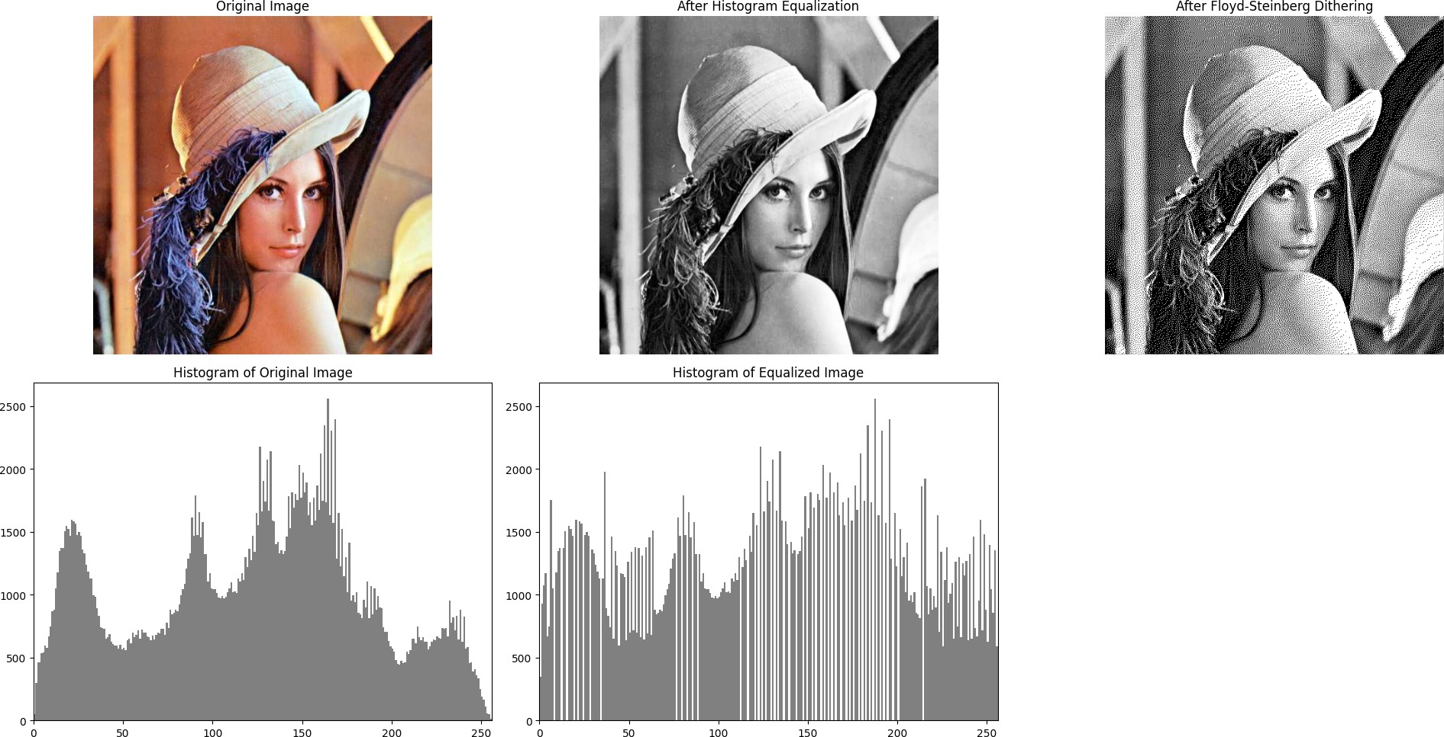

plt.xlim([0, 256])

# Dithered Image and Histogram plt.subplot(2, 3, 3) plt.imshow(dithered_img, cmap='gray') plt.title('After Floyd-Steinberg Dithering') plt.axis('off')

plt.tight_layout() plt.show()